KWAME NKRUMAH UNIVERSITY OF SCIENCE AND TECHNOLOGY
COLLEGE OF ENGINEERING
DEPARTMENT OF AGRICULTURAL AND BIOSYSTEMS ENGINEERING

BSc. Agricultural Eng. and BSc. Landscape and Management
Second Semester 2019-2020

AE 452 Soil and Water Engineering II /AE 478 Soil and Water Conservation

May 2020
ASSIGNMENT C2
Instructions
Answer All Two questions and submit online on or before June 10, 2020
- Describe in detail any method that can be used to measure soil erosion on the field. (Times New Roman; Font 12; one and half spacing; Not more than 2 pages)

- The EI₃₀ for a 120,000 m² maize field was estimated as 23500. Given that the soil has 55 % silt + fine sand, 20 % sand (i.e. 0.10-2.0 mm), 1 % organic matter content and the soil structure is fine granular with slow permeability. If the slope of the land is 6 % with a length 120 m. Provided is erodibility nomograph, conservation practice and crop factor in Figure 1, Table 2 and 3 respectively.
Using the information provided above, Table 2 and 3 and Figure 1 determine using the USLE the following:
- Average soil loss if there is no conservation practice.
- Average soil loss if contour + strip cropping is practice.
- Given that the soil-loss tolerance value as 10 tons per acre, will the practice in (ii) be able to control erosion. Explain your answer.
- If the measures of contour + strip cropping cannot, then what conservation practice will be able to help control erosion
- One intends to break the slope into shorter length and use contouring to manage the land. What length would be most appropriate?
- Between the options of (iv) and (v) what is the best choice and why?

Table 2: Percentage slope and their corresponding conservation practice values
SN | Percentage Slope | Conservation Practice Values
SN | Percentage Slope | Contouring | Contour strip cropping | Terracing and contouring
1 | 1.1 – 2.0 | 0.6 | 0.30
2 | 2.1 – 7.0 | 0.6 | 0.32 | 0.10
3 | 7.1 – 12.0 | 0.7 | 0.35 | 0.12
4 | 12.1 – 18.0 | 0.8 | 0.40 | 0.16
5 | 18.1 – 24.0 | 0.9 | 0.45

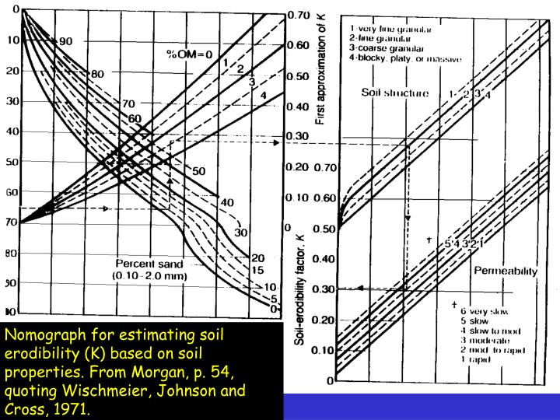

Figure 1: Nomograph for erodibility determination

Table 3. Area covered by different crop types, and C-factor per crop type
Sn | Crop type | C-factor
1 | Common wheat and spelt | 0.20
2 | Durum wheat | 0.20
3 | Rye | 0.20
4 | Barley | 0.21
5 | Grain maize – corn | 0.38
6 | Rice | 0.15
7 | Dried pulses (legumes) and protein crop | 0.32
8 | Potatoes | 0.34
9 | Sugar beet | 0.34
10 | Oilseeds | 0.28
11 | Rape and turnip rape | 0.30
12 | Sunflower seed | 0.32
13 | Linseed | 0.25
14 | Soya | 0.28
15 | Cotton seed | 0.50

